Lecture-9

1. What is partitioning? Why do we need it?
2. What are the different levels of partitioning?
3. Consider a hypergraph H, where each hyperedge interconnects at most three vertices. We model each hyperedge of degree-3 with three edges of weight ½, on the same set of vertices, to obtain a weighted graph G. Prove that an optimal balanced partitioning of G corresponds to an optimal balanced partitioning of H.
4. In refer to Question 3, prove that optimal balanced partitioning of G cannot be done if each edge of H interconnects at most four vertices (i.e., give a counter example).
5. Explain Kernighan-Lin algorithm for partitioning a graph. Find its time complexity.
6. Consider a path graph v1, v2,….., vn. That is, v1 is connected to vi+1, for 1 < i < n-1. Apply the Kernighan-Lin algorithm to this graph. As the initial partition, let va, for all odd values of a be in one set , and vb, for all even values of b, be in the other set.
7. Consider a complete binary tree with n nodes. Apply Kernighan-Lin algorithm to this graph. As the initial partition, let va, for all internal vertices, be in one set and vb, for all leaves, be in the other set.
8. Show how the Kernighan-Lin Heuristic works on the ladder graph with 2n vertices, starting with initial partition of V1= {1,2,3,……,n}, and V2={n+1,n+2,n+3,…..,2n}.

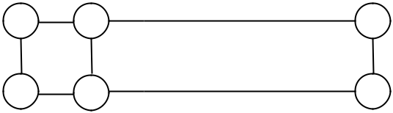

|  |  |  |
| --- | --- | --- |
| 1 | 2 | n |
| n+1 | n+2 | 2n |

Fig. 1

1. What are the drawbacks of Kernighan-Lin algorithm?
2. The following matrix provides 4 modules a,b,c,d with their entries representing the number of connections between the two modules. Apply Kernighan-Lin heuristic to obtain the partitioning.

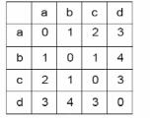

Fig.2

Lecture-10

1. What are the advantages of Fiduccia-Mattheyses algorithm over Kernighan-Lin algorithm?
2. What are the similarities between Fiduccia-Mattheyses algorithm and Kernighan-Lin algorithm?
3. Present the Fiduccia-Mattheyses Algorithm. Find out its time complexity.
4. Apply Fiduccia-Mattheyses Algorithm for the problem in question 7.
5. Apply Fiduccia-Mattheyses Algorithm for the problem in question 8.
6. Apply Fiduccia-Mattheyses Algorithm for the problem in question 10.
7. “There is a trade off associated for partitioning with replication.” Is it true or false? Justify.
8. Discuss how Partitioning is affecting overall delay.
9. What do you understand by performance driven partitioning?
10. Discuss the approach of clustering in case of partitioning.